**Step By Step Procedure for android Go-Translate Contribution**

This App can enables a translator / post-editor to contribute / rectify the translations. Translator can contribute new translations after successful login. In order to translate/post-edit, various MT systems are also integrated to aid the translator/post-editor in contributing the right translation. The translator/ post-editor can copy and paste the MT suggestions and also can make use of the virtual keyboard to edit or contribute a new translation. Once the translator/post-editor clicks on the contribute button all the new/post-edited contributions will be stored on the big-store on a remote server.

Step 1 :open **Go-Translate App** in your smart phone.



Step 2 :Give your username and password.

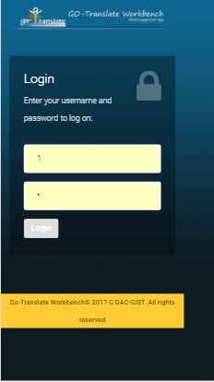

Step 3 :Click on Login Button. It will process and Gives you English Text for Translation. Select Language For which you want to make contribution.

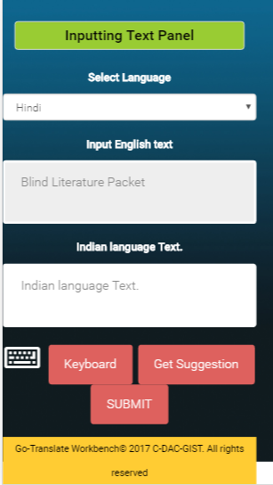

Step 4 :Some Indian Language Translation Suggestion is provided by App. click on Copy Button that suggestion will reflect in Indian language Textbox.

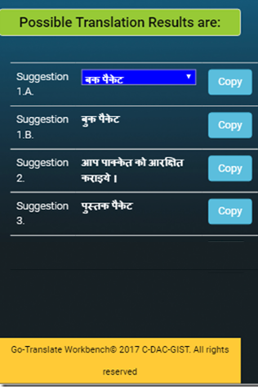 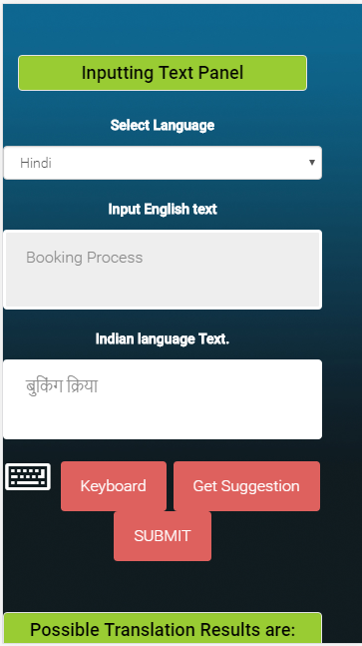

Step 5:User can Click on Submit Button.App Will ask for Next English Suggestion for translation or Quit the application.

